* **MAULANA AZAD NATIONAL INSTITUTE OF TECHNOLOGY**

**Date:** 15/02/2021

|  |  |  |
| --- | --- | --- |
| **Subject** | **DBMS LAB** | **Session: Jan- 2021** |
| **Sub. Code:** | **CSE-227** | **Semester: IV (CSE)** |
| **Name of Teacher** | **Dr. Sweta Jain, & Dr. Nikhil Kumar Singh** |  |

**DBMS: LAB-ASSIGNMENT 15-02-2021**

Query 1:- Get the name of employees who earn a salary of more than 30000$.

select Fname,Minit,Lname from employee where salary > 30000;

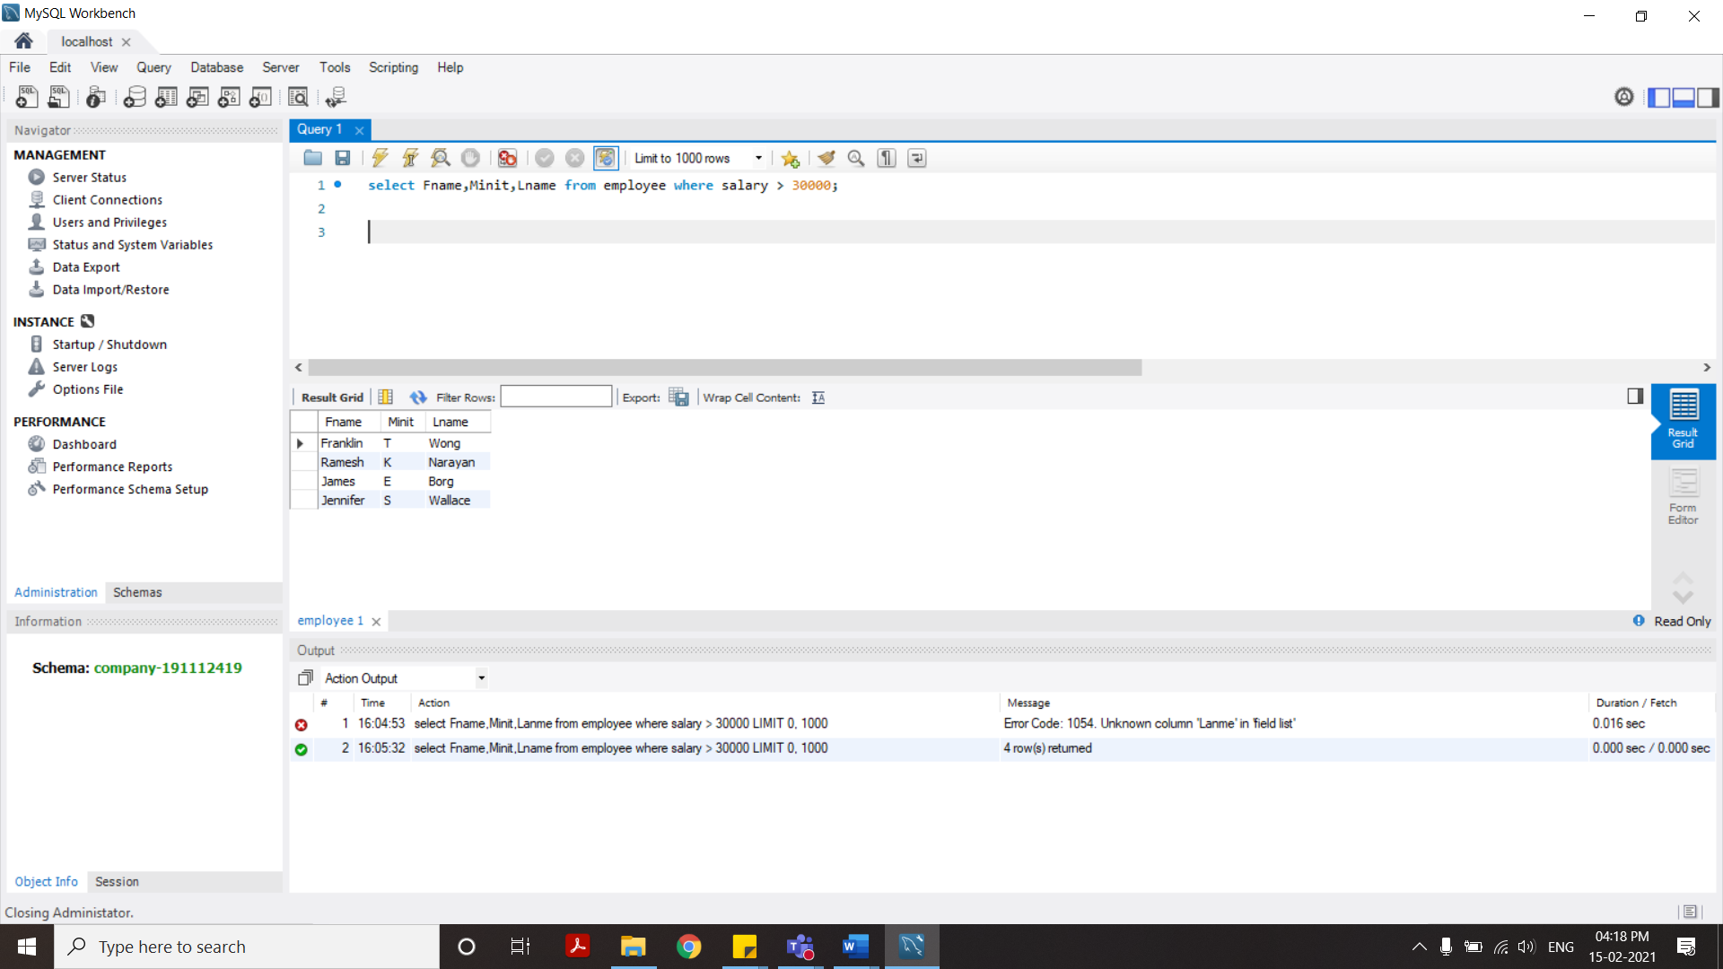

Query 2: Get the name of the employee whose last name begins with ‘W’

select Fname,Minit,Lname from employee where Lname like 'W%';

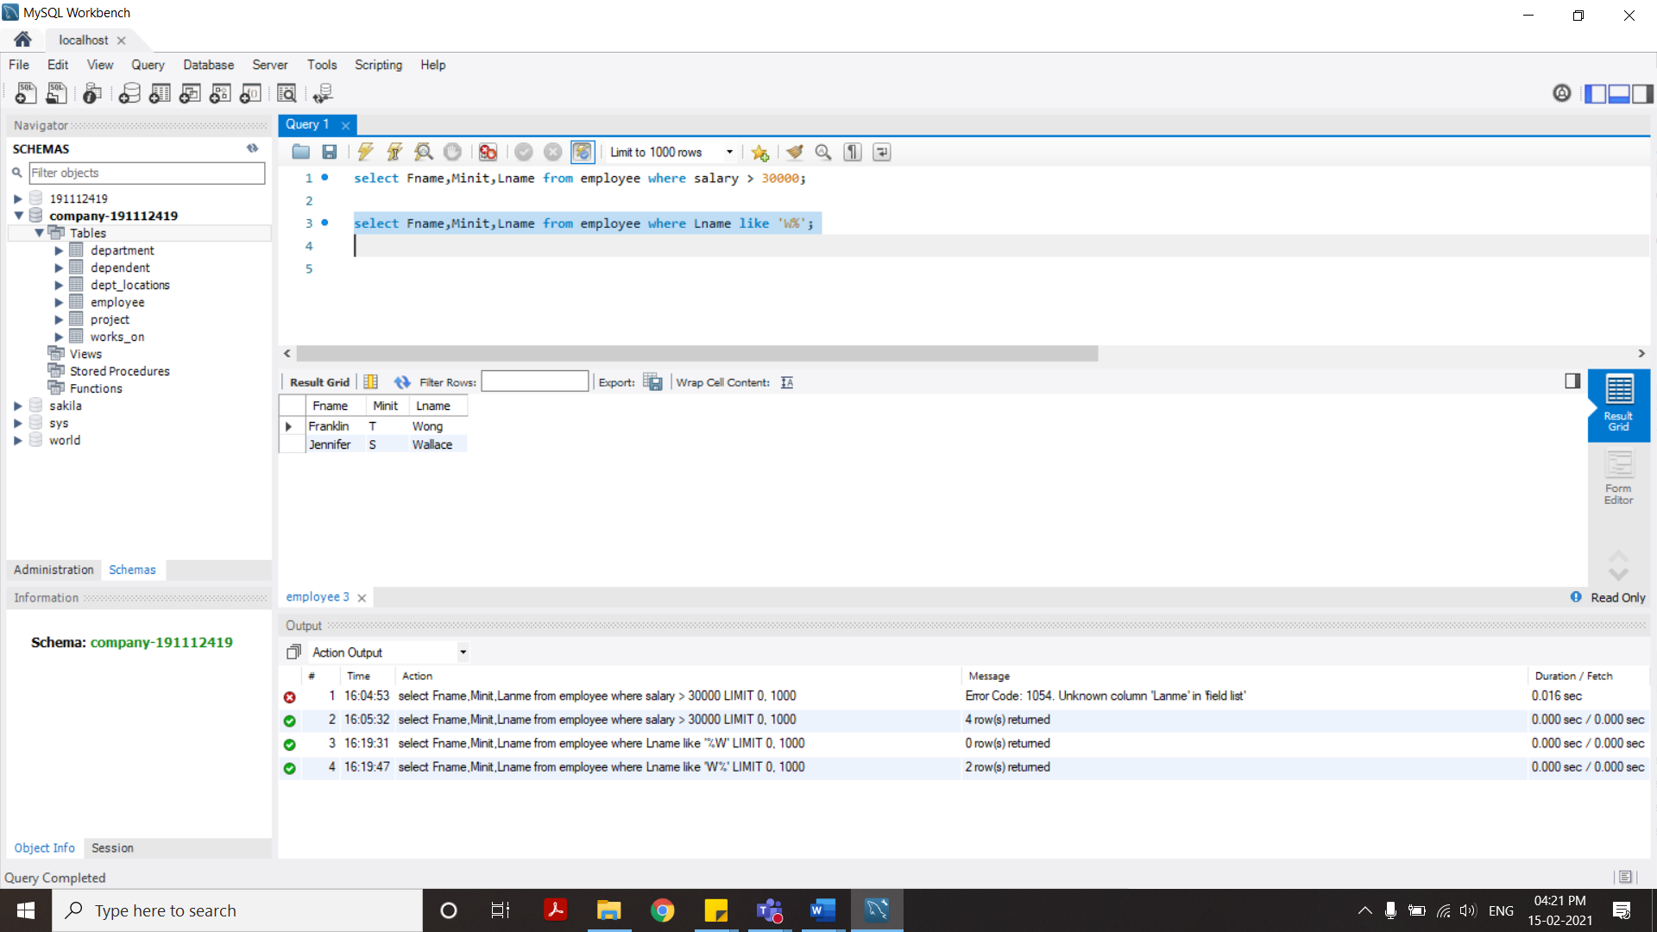

Query3: - If the Company wants to give increment to those employees who earn less than 25000$ by 10%, then get the increment amount of salary.

select Ssn, Fname, Salary + Salary*0.1 as Incremented_Salary from employee where Salary<=25000;

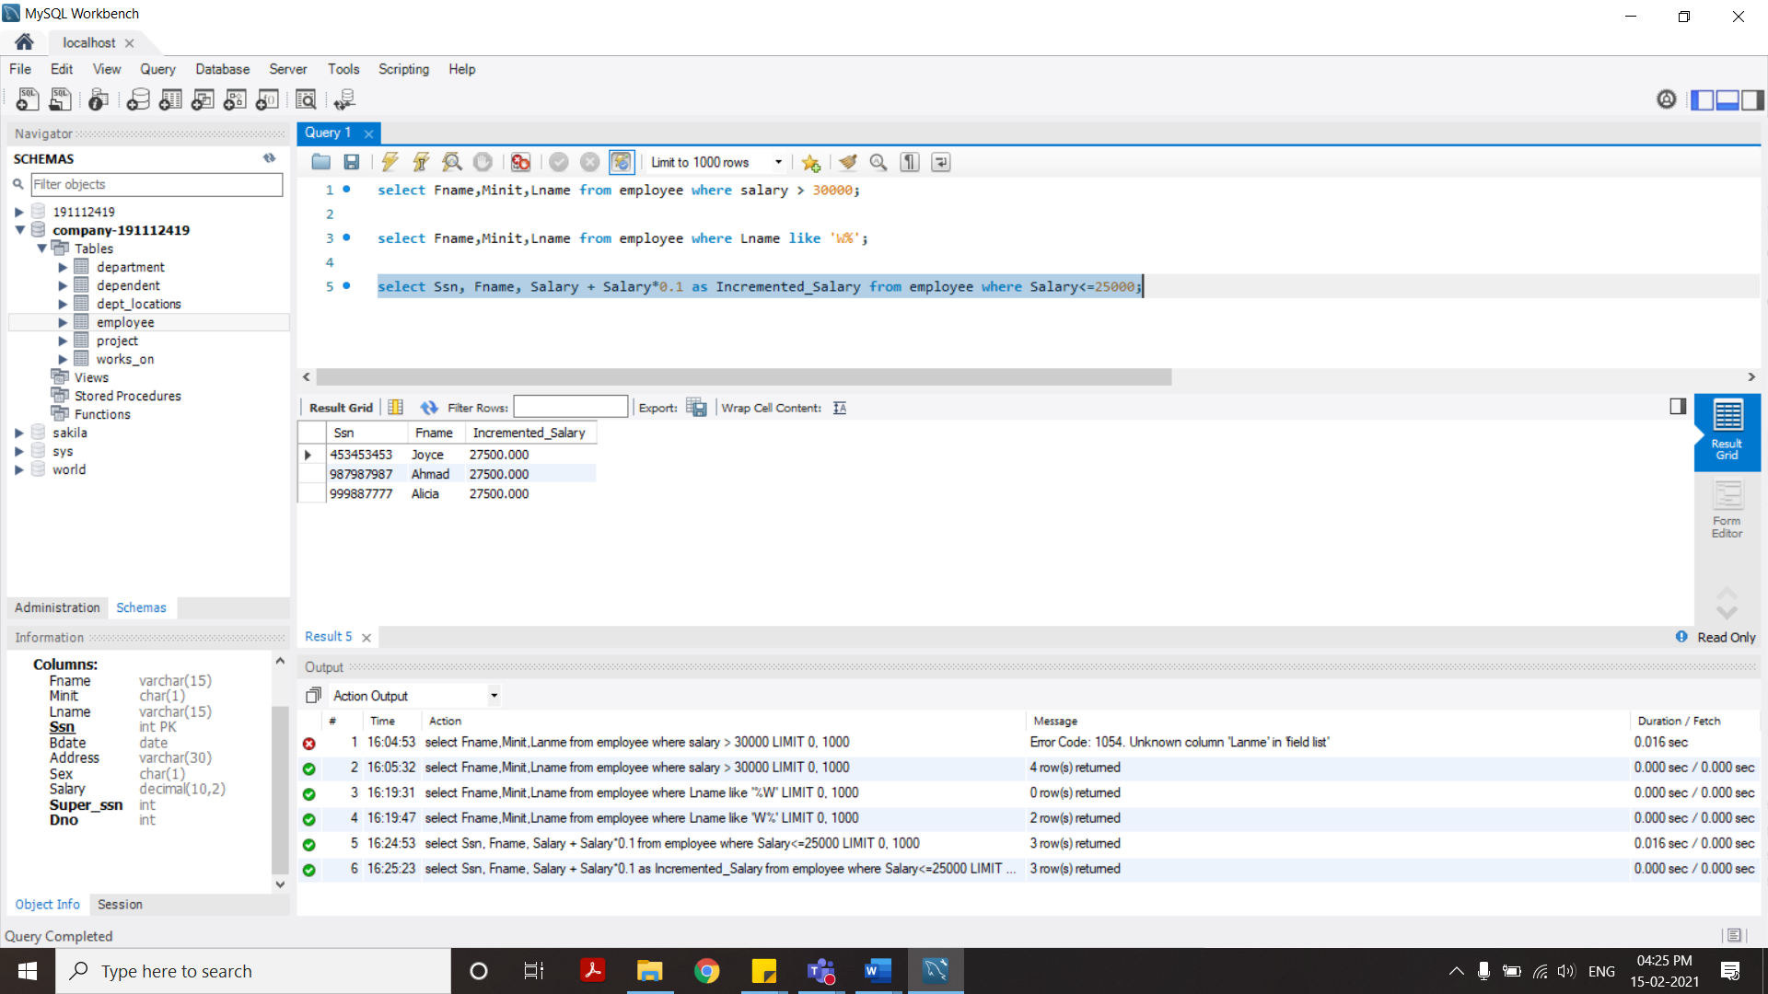

Query 4: Get the department number whose belongs to a location that name end with ‘D’

select Dnumber from dept_locations where Dlocation like '%d';

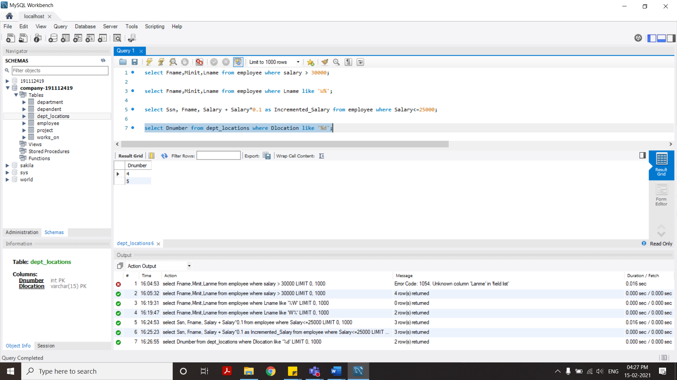

Query 5: Get the detail of employee in sorted form according to their salary in increasing order.

select * from employee order by salary asc;

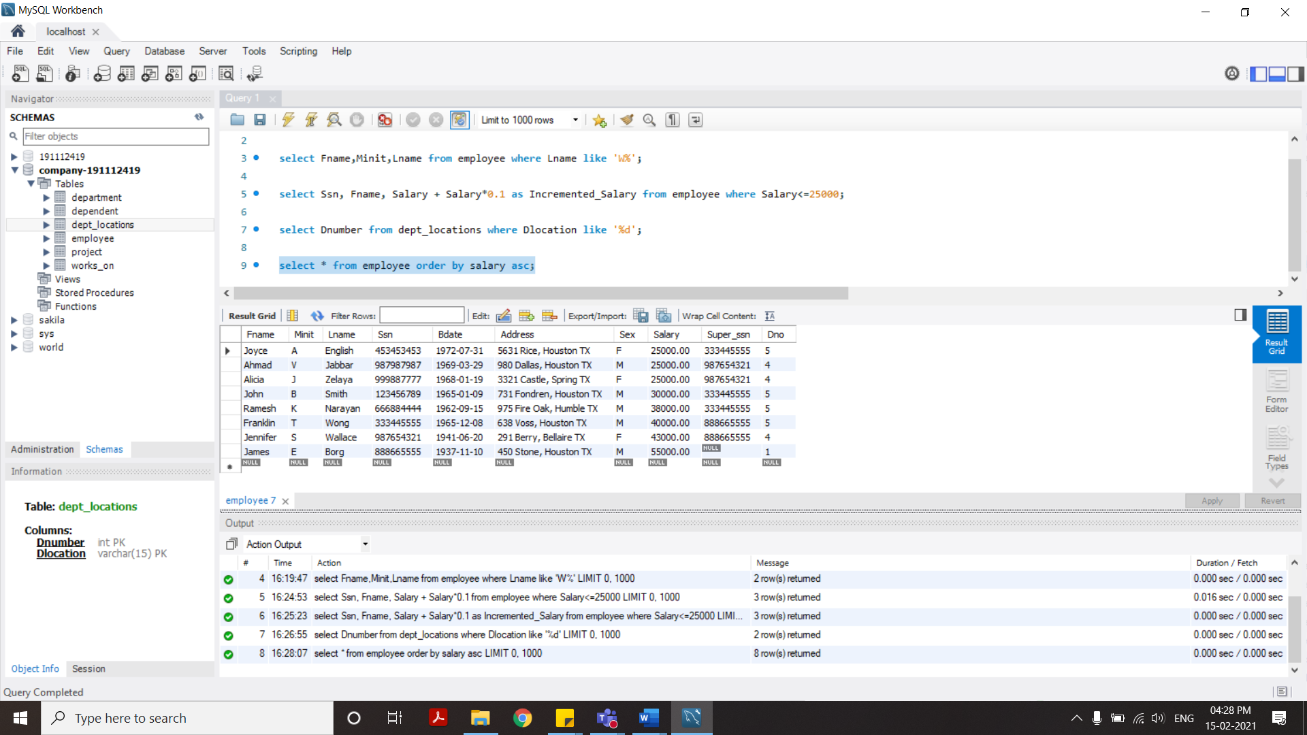

Query 6: Get the details of employee who works in the headquarters and research department. (By using IN clause)

select * from employee where Dno in (select Dnumber from department where Dname in ('Headquarters','Research'));

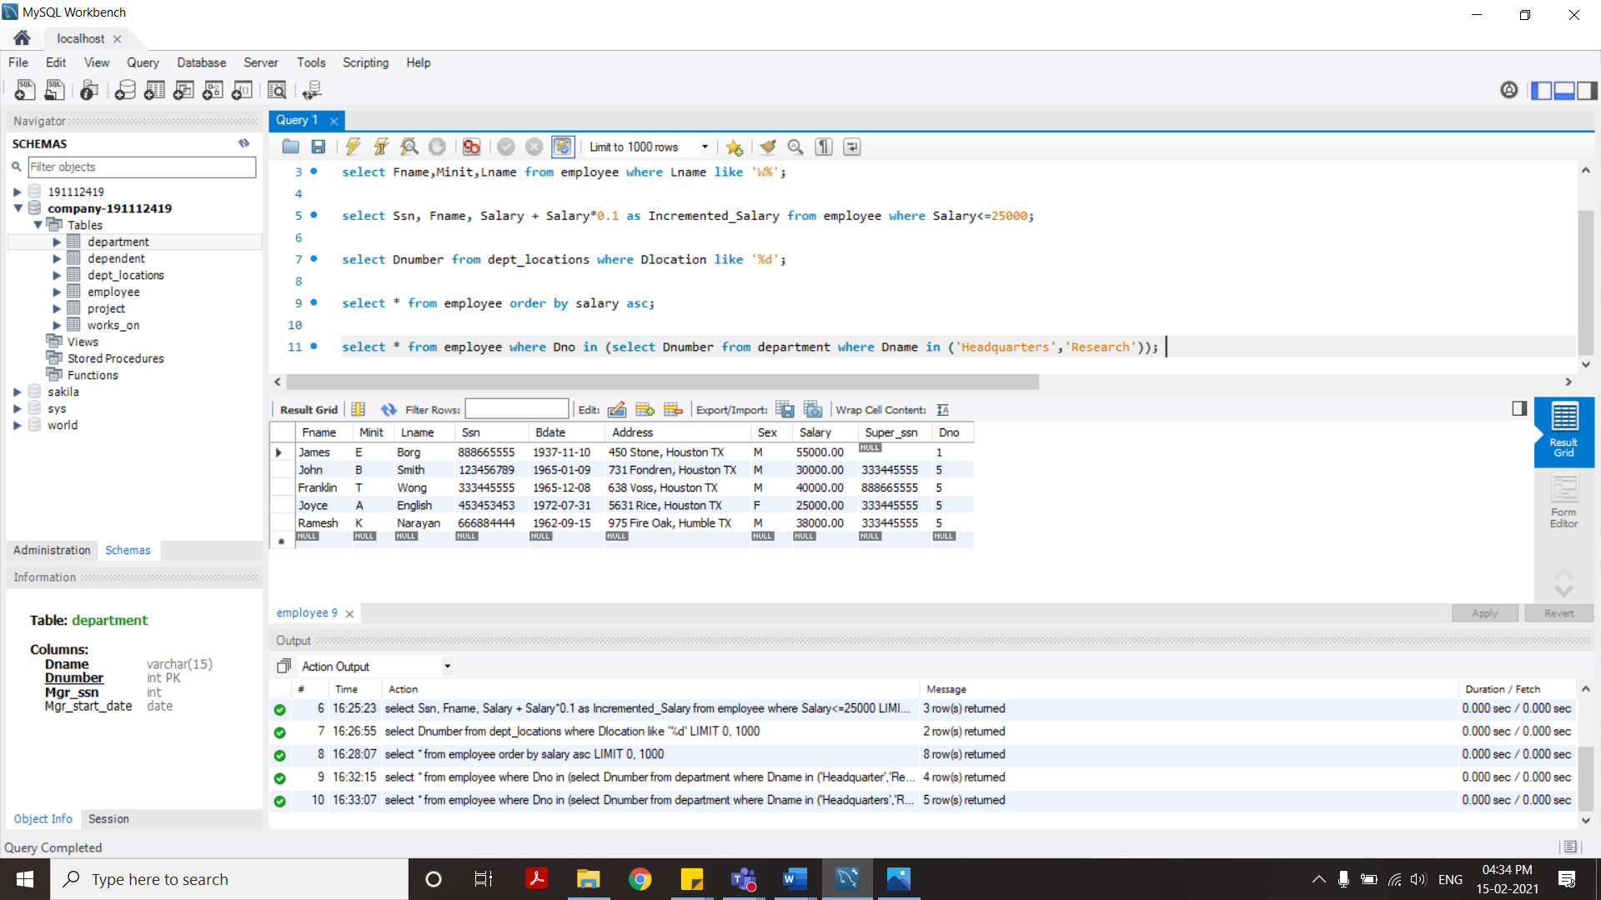

All Sql Queries:

select Fname,Minit,Lname from employee where salary > 30000;

select Fname,Minit,Lname from employee where Lname like 'W%';

select Ssn, Fname, Salary + Salary*0.1 as Incremented_Salary from employee where Salary<=25000;

select Dnumber from dept_locations where Dlocation like '%d';

select * from employee order by salary asc;

select * from employee where Dno in (select Dnumber from department where Dname in ('Headquarters','Research'));